31.69: a) From the current phasors we know that
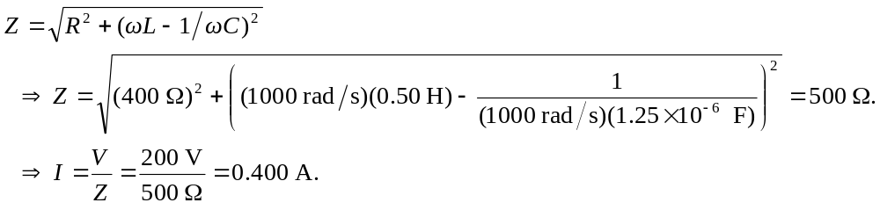
b) 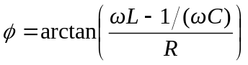
c) 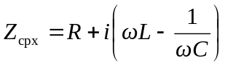
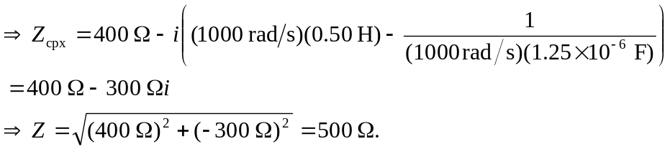
d) 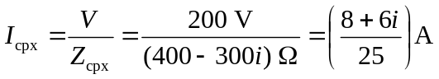
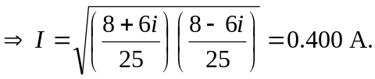
e) 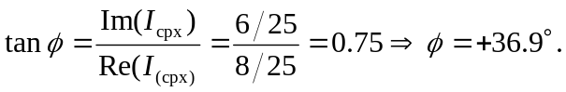
f) 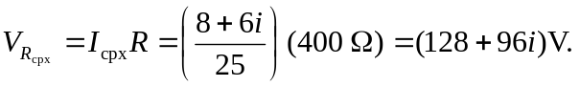
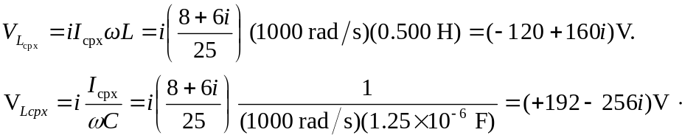
g)
